Deep Space Galley Design Study

Erin Sylve

Jon Vega

Madalyn Wilemon

Completed to fulfill ISEN 489.501 Semester Project

Dr. Nancy Currie-Gregg

April 29, 2021

**“An Aggie does not lie, cheat or steal or tolerate those who do. On my honor as an Aggie, I have neither given nor received unauthorized aid on this academic work.”**

This is entirely my own work or ― if authorized by my instructor ― the work of the team I was assigned to ― except as documented in a bibliography or acknowledged below.





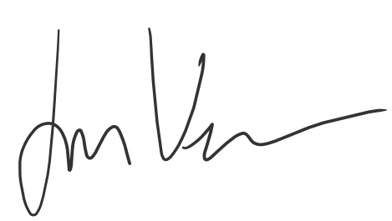

# Table of Contents

# 

1. Executive Summary 2
2. Introduction 3
   1. Problem Statement 3
   2. Motivation for the Study 3
3. Background 3
   1. Concept Application 3
   2. Literature Review 4
4. Methods and Findings 8
   1. Human Factors Design Requirements 8
      1. Adopted Requirements 8
      2. Proposed Requirements 10
   2. Iterative Conceptual Design 11
   3. Task Analysis 13
5. Discussion 16
   1. Key Results 16
   2. Recommendations 18
6. Conclusion 18
7. References 19
8. Appendices 21

# Executive Summary

The current Galley system design does not achieve basic levels of habitability necessary for long-term missions in deep space. The galley must be designed to prevent illness and malnourishment of the crew. In order to achieve this, research needed to be done to understand the current state and an ideal future. Literature reviews explained the evidence for nutritional risk and the tasks that must be completed to close the gap. Further research was conducted to understand the current designs used and suggested for future missions. Requirements are defined using existing requirements from the NASA Human-System Standards. Additional requirements are defined to fit long-term mission durations. An iterative design addresses each of the requirements presented. The addition of greater freeze-dried food storage, fresh food storage, refrigerator, and freezer allow more food to be kept in the galley. An addition of a 3D Printer and plant growing system allows food to be created during the mission, saving on the space required for transport and adding to the variety of the menu. A task analysis was created to evaluate the cognitive workload required of operators using the galley. Plans were outlined to conduct human-in-the-loop evaluations measuring time, heart rate, glance duration, and subjective evaluation of the usability. In the future, displays and details on the integration of each appliance needs to be addressed.

# 

# Introduction

## Problem Statement

The National Aeronautics and Space Administration (NASA) has identified that the next step of human spaceflight is entering, inhabiting, and exploring deep space. Evidence shows that current Galley System Designs are not prepared for long-duration missions such as the Artemis Deep Space Gateway (Human Research Program, 2016). To provide a space that will prevent deleterious effects on individuals’ long-term physical and mental health, the Galley System Design must achieve livability, usability, and flexibility appropriate for a 3 to 5 year-long mission.

## Motivation for the Study

NASA defines the current risk faced as a performance detriment and crew illness due to inadequate food and nutrition. By accounting for food system changes due to processing, storage, choice, and eating environment, the sensory and psychological acceptability of the food can improve to a basic level of habitability. Proper nutrition requires the astronauts to receive appropriate amounts of micro/macro nutrients as well as avoid harmful microbiology that may form on the food or as a result of food preparation. Deep space applications are especially challenging in that previously unaddressed issues, such as long-term storage, food production sustainability, and nutrition density must take high priority. This design study seeks to investigate how to improve the habitability of the galley by addressing each of the aforementioned challenges.

# 

# Background

## Concept Application

The Deep Space Galley Design Study applies the concepts presented on habitability as the core of the study’s research question: How can the galley design achieve habitability appropriate for a 3 to 5 year mission? How can the livability, usability, and flexibility each be improved? The anthropometric considerations presented are used in the scaling of the system. Reach envelope and grip strength are not violated by the design. The human-centered design process guides the study’s approach to answering the research question. The concept of operations is defined by research through the literature review. This includes previous designs, environmental conditions, risks, and failure scenarios. An iterative conceptual design process is implemented and followed by a proposed task analysis. The analysis plan implements several of the discussed measurements including an empirical, subjective, and physiological measurement to determine cognitive workload. Continuing the plan calls for continued in-situ monitoring of human-system performance.

## Literature Review

The objective of the literature review was to provide a basis to aid in answering this design study’s main research question: How can the galley design achieve habitability appropriate for a 3 to 5 year mission? The literature search began with the Risks and Gaps page created for the Human Research Roadmap Web Pages by NASA. There the Evidence Report on Nutritional Risks was found.

Human Research Program. (2016). [*Risk of Performance Decrement and Crew Illness Due to an Inadequate Food System*](https://humanresearchroadmap.nasa.gov/Evidence/other/AFT.pdf) (pp. 2-48, Rep.). Houston, TX: National Aeronautics and Space Administration.

Summary: Food and Nutrition are central to the safe operation of the crew and care must be taken to ensure performance, acceptability, and safety are designed into systems surrounding Food intake. This document presents the evidence there is for risk in these aspects of long-duration missions and the gaps that must be filled before these missions begin. Food is likely to be sent into space years before astronauts on separate missions and may be 3 to 5 years old by the time astronauts eat it. Risks of this time frame and the different types of foods to account for are defined. Possible solutions are outlined.

The evidence report identifies the Food-2 Gap as “needing to determine how the sensory and psychosocial acceptability of the food system changes due to microgravity, processing, storage, choice, and eating environment.” Three tasks from the Food-2 Gap guide the search forward.

1. Effects of Retronasal Smelling, Variety, and Choice on Appetite and Satiety
2. Factors Contributing to Food Acceptability and Consumption, Mood, and Stress on Long-term Space Missions/Food Variety in Free-Living Adults
3. Food Acceptability, Menu Fatigue, and Aversion on ISS Missions

Each is used to find the following works of literature that were listed as sources in the Evidence Report.

Caldwell BJ, Halpern BP, Binsted K, Hunter JB. Menu Fatigue During 70-Day 6° Heat-Down Tilt: Initial Results. In: NASA Human Research Program Investigators' Workshop, Galveston, TX, 2014. NASA. <https://www.researchgate.net/publication/285057421_Menu_fatigue_during_70-day_6_head-down_tilt_initial_results>.

Summary: This study aims to gauge the variability of menu fatigue as an effect of bed rest. This head-down tilt illustrates the experience an astronaut may have in a low-gravity environment and explored overall moods and food acceptability. Over 70 days, individuals were polled for the hunger/satiety around each meal, and the mood and perceived health were observed in the evening. As a result, individuals experienced a loss of appeal for certain foods, but patterns of menu fatigue did not appear to be correlated with the effects of the head-down tilt.

Hetherington M, Pirie L, Nabb S (2002) Stimulus satiation: effects of repeated exposure to foods on pleasantness and intake Appetite 38:19-28 <https://pubmed.ncbi.nlm.nih.gov/11883914/>

Summary: A study done between two groups of normal-weight, healthy men showed that when given a food item they liked repeatedly, the subject’s perceived pleasantness of that food decreased over time though their intake did not change. One group was given a well-liked food, chocolate, while the other group was given a moderately-liked food, bread and butter. While both groups saw a decrease in how much subjects said they liked the food, neither group saw a significant decrease in consumption. This suggests that though a person may not like the food as much over a long period of eating it, they may still want to eat the food.

Locher JL, Yoels WC, Maurer D, van Ells J (2005) Comfort foods: An exploratory journey into the social and emotional significance of food Food. <https://www.tandfonline.com/doi/abs/10.1080/07409710500334509>.

Summary: The paper attempts to analyze and examine the construct of comfort foods, emphasizing how cultural studies should be considered in social and physiological frames. The study goes as far as categorizing different types of comfort foods in an effort to describe how certain foods are associated with changes in emotional states or feelings. The main goal of the study was to understand how mood plays into the role of selecting food items.

Shiraseb F et al. (2016) Higher dietary diversity is related to better visual and auditory sustained attention The British journal of nutrition:1-11 doi:10.1017/S0007114516000428. <https://pubmed.ncbi.nlm.nih.gov/26902532/>.

Summary: This study aims to determine if there is a relationship between improvements in dietary diversity and sustained attention. Researchers utilized an Integrated Visual and Auditory Continuous Performance Test and a dietary recall questionnaire to conduct their experiment. The study finds that as diversity in diets increases, visual and auditory attention increases as well.

Vickers Z (1999) Long-Term Acceptability of Limited Diets Life Support and Biosphere Science 6:29-33. <https://www.researchgate.net/publication/11803990_Long-term_acceptability_of_limited_diets>.

Summary: This paper analyzes the long-term acceptability, or liking, of foods eaten often. Researchers of the experiment implemented sensory-specific satiety to measure the long-term acceptability of repeatedly eaten foods as taste test measurement data can be misleading.

Zellner DA, Loaiza S, Gonzalez Z, Pita J, Morales J, Pecora D, Wolf A (2006) Food selection changes under stress Physiol Behav 87:789-793 [doi:10.1016/j.physbeh.2006.01.014](https://psycnet.apa.org/record/2006-04271-018)

Summary: This paper is about two studies that investigate the effects of stress and the selection of food. Experiment 1 concludes that stress influences the selection of food choices from healthy low-fat foods to less healthy high-fat foods. In Experiment 2, it is determined that females report an increase in food consumption as opposed to males when stressed. Both studies highlight how stress affects the selection of food.

To better understand the current design and potential for the future design of the galley. A google search was conducted using the phrases “ISS Galley Design” and “Cooking in Space.” The literature and figures 1 & 2 below aided in the basic understanding of current designs.

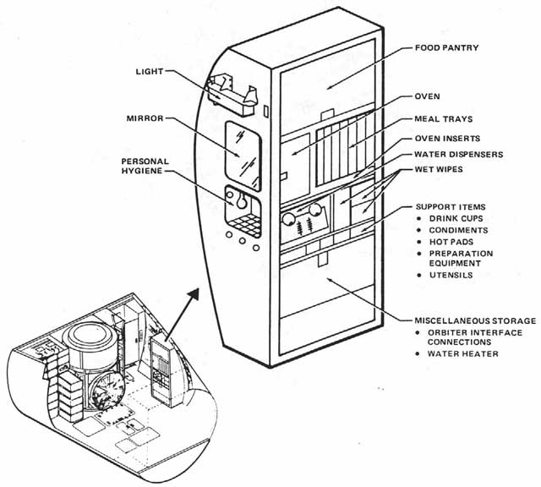

Figure 1. Space Shuttle Galley Design

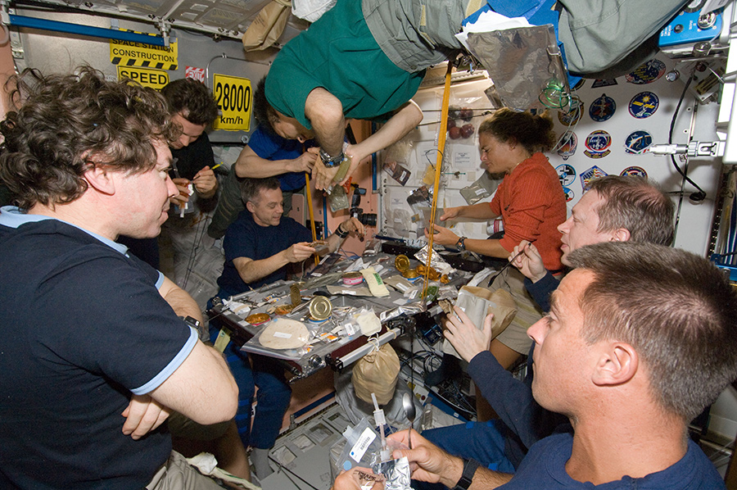

Figure 2. Crewmembers gathering for a meal on the ISS

Khodadad, C., Hummerick, M., Spencer, L., Dixit, A., Richards, J., Romeyn, M., . . . Massa, G. (2020, February 11). Microbiological and nutritional analysis of Lettuce crops grown on the International space station. Retrieved April 16, 2021, from <https://www.frontiersin.org/articles/10.3389/fpls.2020.00199/full>

Summary: Lettuce grown in the “Veggie” Chambers on the International Space Station, were instrumental for improving the nutritional value of astronauts' diets while on the Space Station. Plants are grown under magenta light from “pillows” of nutritional clay medium. The lettuce was measured for the number of micronutrients it provides as well as its biological hazard to the crew. The bacterial counts and variety on both the flown plants and the control plants on earth were not significantly different. Both were found to be in low, non-harmful levels. There were no significant differences found in elemental micronutrients and small differences in the antioxidants provided.

Dunbar, B. (2010, October 23). Food and cooking in space. Retrieved April 01, 2021, from <https://www.nasa.gov/mission_pages/station/expeditions/expedition18/journal_sandra_magnus_7.html>

Summary: This feature describes what it is like to cook in space, as told through the experiments done by astronaut Sandra Magnus. Most of the process requires plastic bags to hold ingredients, foil bags to cook in, and duct tape to hold everything down. From there it is a matter of transferring ingredients to cut and combine them. She explains that the most difficult parts of cooking in space are that food will stick to utensils and bags when it has high liquid content and that the food warmers take hours to cook ingredients, so time is a necessary consideration.

Shafiee, M. N. (2017). [Space Food Technology: Production and Recent Developments.](http://www.ijoart.org/docs/Space-Food-Technology-Production-and-Recent-Developments.pdf?fbclid=IwAR24icHZAH9T7aJ4l7y0hHt_-NADj-w7QG5qPARSP5dWrKyLsMFQcgeUkY8) *International Journal of Advancements in Research & Technology,* *6*(2), 120-129.

Summary: This paper describes how food in space has been produced and some of the developments over time. Food needs to provide proper nutrition, it also needs to be easily stored and have the capability to be stored for a long duration. In recent years, food developments have allowed astronauts access to elaborate menus and full courses, despite challenges of food preparation and consumption in a weightless environment. The paper explains how food is produced before being sent to space, how nutritional factors are met, and how it is packaged and consumed.

# Methods and Findings

## Human Factors Design Requirements

The design requirements are dictated by the goal to improve the habitability of the galley. The first set of design requirements are already approved and used by NASA. They do not need to be amended so they have been adopted as listed in the handbook.

### Adopted Requirements

The following requirements and their rationale can be found in the NASA-STD-3001 Vol 2 Rev B Section 7:

1. The system shall provide the capability for preparation, consumption, and stowage of food.

The requirement addresses the purpose of the Galley system, providing food that the crew is willing and able to eat. This requirement is verifiable by a combination of testing and inspection. Some things like the stowage necessary for food, and a method to open packaging are able to be confirmed visually, however other things like whether crewmembers feel comfortable consuming the food can only be determined through usability testing.

1. The food system shall allow the crew to unstow supplies, prepare meals, and clean up for all crew members within the allotted meal schedule.

This requirement ensures the mission is not negatively impacted by the time necessary to dine. This is verifiable by testing and analyzing the time required to complete tasks.

1. The food storage, preparation, and consumption areas shall be designed and located to protect against cross-contamination between food and the environment.

This requirement is critical to the health and safety of everyone on board. Food must be processed, stored, and cooked properly to avoid contamination concerns. It is also critical that the waste management systems are kept completely separate from the food preparation systems. This requirement is verifiable by analysis of samples taken from surfaces around the food preparation area.

1. The system shall provide the capability to heat food and beverages to a temperature appropriate for the given item.

Heating increases the palatability of some foods, which is important for the crew’s psychological health. This system is not mission-critical, but to endure the long mission duration, it is necessary to improve the perceived quality of life (Hetherington, 2002). This is verifiable by subjective testing.

1. Crew Members shall have the capability to dine together.

Once more, the mental health of the crewmembers, especially on long-duration missions, is a major concern. It has been shown that allowing the crew to dine together improves the crew’s psychological health and well-being. This is verifiable by inspection. The table should be large enough for more than one crew member to fit.

1. The system shall provide readily accessible trash collection and control of food system waste.

It is necessary to plan through the end of the life cycle for food waste. The physical health of crew members depends on having some sort of collection system. This is verifiable by inspecting whether there is a place for waste to be collected or not.

1. The system shall provide the ability to control and remove food particles and spills.

Cleaning up spills helps prevent contamination, which can lead to illness in the crew. This requirement can be verified by inspection of whether such a system is provided.

1. The system shall provide methods for cleaning and sanitizing food facilities, equipment, and work areas.

This requirement also aids in the prevention of contamination and illness of the crew. Similarly, this requirement can be verified by inspection.

### Proposed Requirements

The following additional requirements were developed to close the gap between current requirements and what is necessary for long-term missions. These requirements are guided by the tasks from the Food 2 Gap.

* 1. The system shall allow storage with space for the food necessary for a 1-3 year long mission.

When planning for a multi-year long mission, not only does food need to have a shelf life that will allow it to last the entire duration, but there will need to be enough room for all of the food. A crew facing minimal gravity environments will need to consume enough to maintain a healthy body mass. Foods with naturally long shelf lives, such as canned and dry goods, will be very common, but nutrition requirements may necessitate other types of food to be present. Irradiation of fresh foods may allow for extended shelf life. This requirement can be verified by analysis of the volume provided by each storage configuration in the design.

* 1. The system shall allow the dispensing of potable water.  
       
     Water is essential for all living organisms. For this system, sufficient water will be necessary for the crew’s physical and mental health. Current applications utilize water recovery systems to reuse and recycle water sources, allowing for minimal storage. Within this system, similar water recovery systems will be in use. This requirement will be verified by the inspection of whether such a system is in place.
  2. The system shall be equally accessible for all crewmembers, from the 95% American male to the 5% Japanese female defined by NASA-STD-3001 Vol 2 Rev B Section 4.

Crewmembers may be individuals from any area within this range of anthropometry. It is important to be sure that there is an equal usability for all accessing the components within the system. Microgravity does create anthropometric changes within the body, such as spinal elongation that must be accounted for. This requirement can be verified through analysis of usability testing.

* 1. The system shall have the capability of cultivating crops.

While storage can be adjusted to allow maximal food storage, long-term applications should be able to produce fresh crops. This necessitates that the system is able to cultivate crops, such as vegetables, for astronauts to grow and consume. This requirement is verifiable by a demonstration of the system designed to grow crops in microgravity.

## Iterative Conceptual Design

* + 1. Iteration 1

The first iteration of the design pictured in figure 3 below, was a general shape of where things should go, what should be included, and how the system would fit within the overall station.

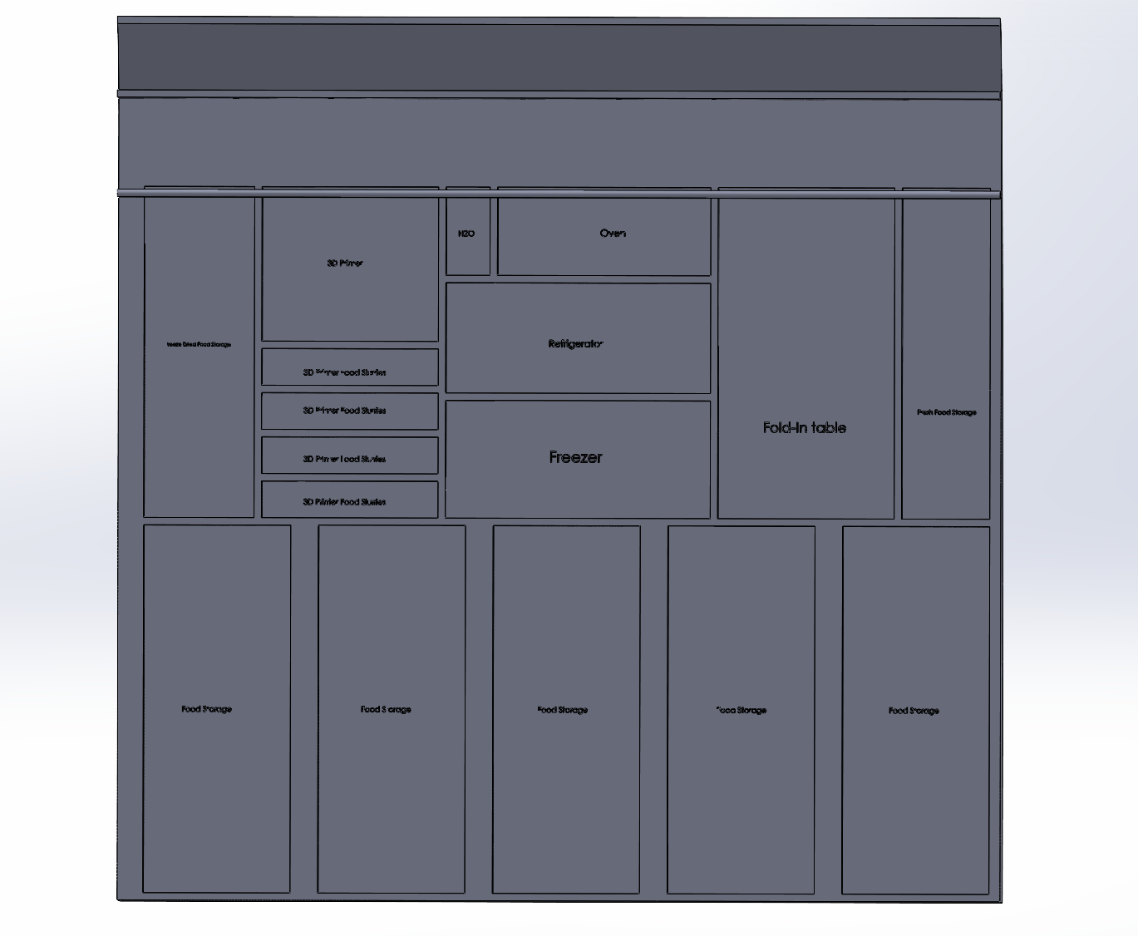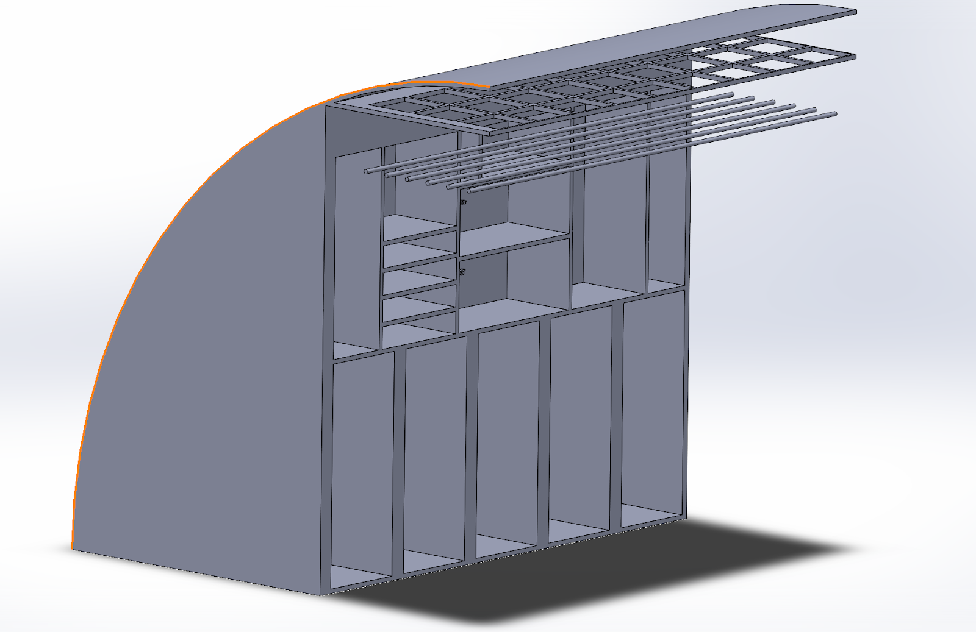

Figure 3. Iteration 1 Design

The design was shaped to fit within a similar design to the International Space station, where total pressurized volume is much larger than the habitable area, allowing for more storage. Dimensions, more specific designs for each subsystem, and renderings would come later.

* + 1. Iteration 2

The second iteration of the design, in figure 4 below, calculated the proper dimensions of what should be included where. These measurements are provided in Appendix A. The included appliances that are currently experimental, but still contracted by NASA were included (Shafiee 2017). This includes a 3D Printer, Oven, Fridge, and Freezer (Garfield, 2017). All placement is finalized and representative of both the second and third iteration of the design.



Figure 4. Iteration 2 Design

* + 1. Iteration 3

The third iteration of the design included the specific designs for usability and flexibility necessary for an overall habitable system. The rendering was produced. This is the system as it would be presented for testing.

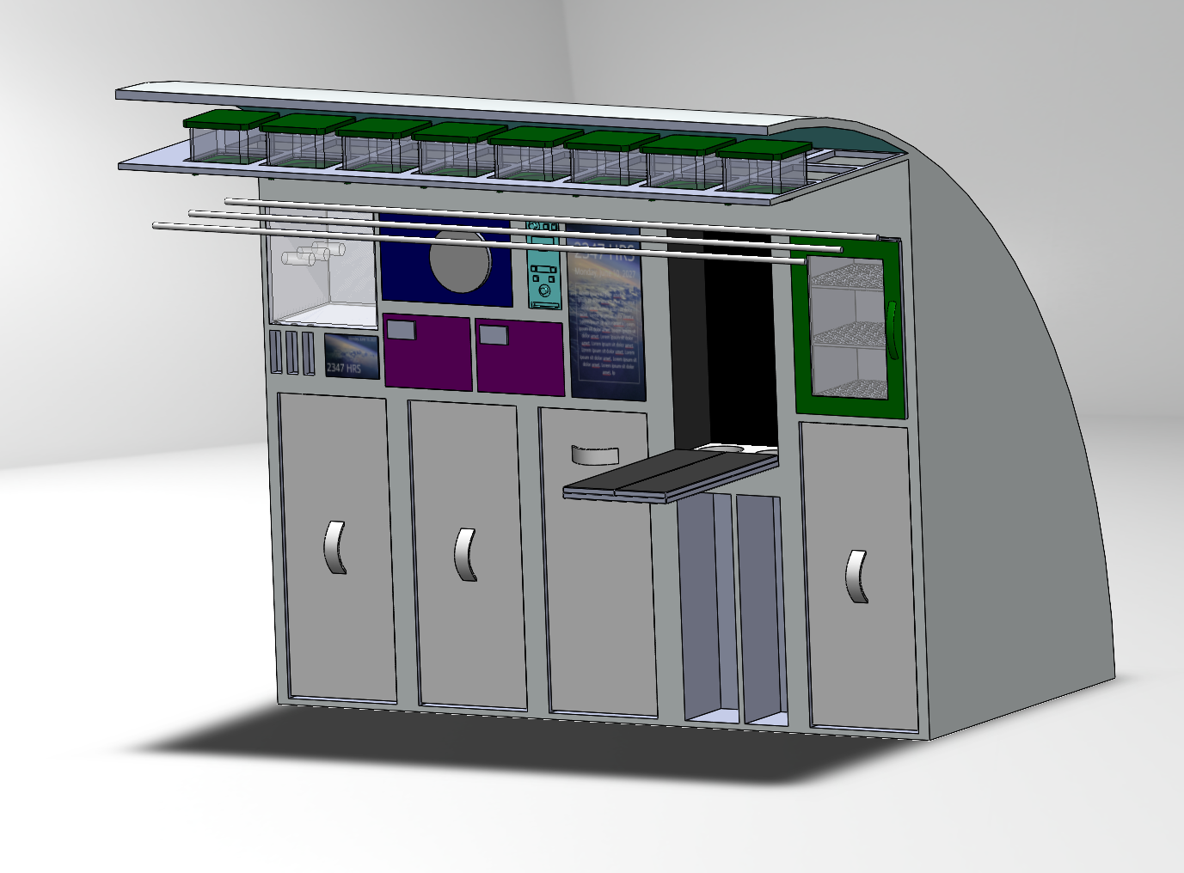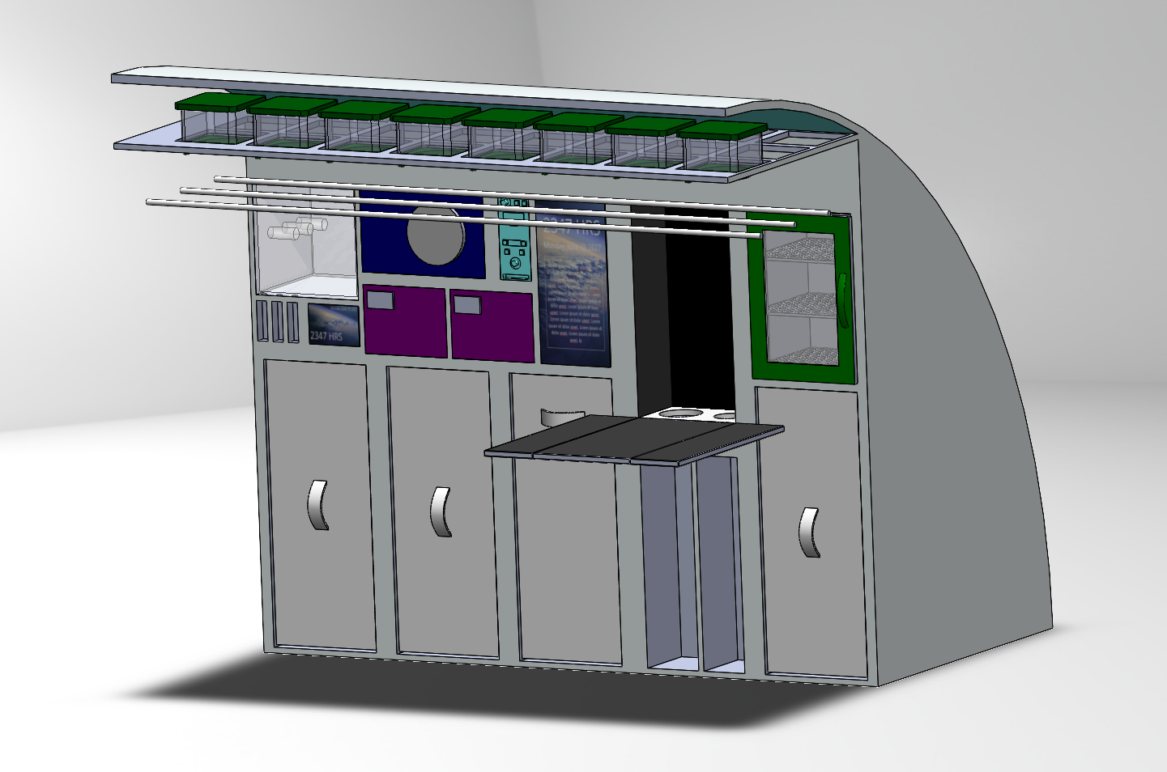

Figure 5. Galley with Table Folded and Unfolded.

The shape of the station is assumed to be semi-circular similar to the International Space Station. The very top of the galley is home to the PODS system for growing plants. Plants grow toward the floor, protected by rods of lights. The first row of the galley, from left to right includes the 3D printer and display for controlling it, oven, water dispenser, fridge, freezer, assistant display, fold-out table, and fresh food storage.

The assistant display shows a recreated view from outside the ISS in standby mode, and allows crewmembers to look through recipes or manuals while cooking. It keeps track of cooking times and temperatures. The display may also be used for communication with crewmembers and keeping track of schedules.

The fold out table fits 1 - 2 crew members while folded and 4 - 5 once unfolded. Behind the fold out table the compartment is covered with velcro for storage. The top of the table is also covered with velcro.

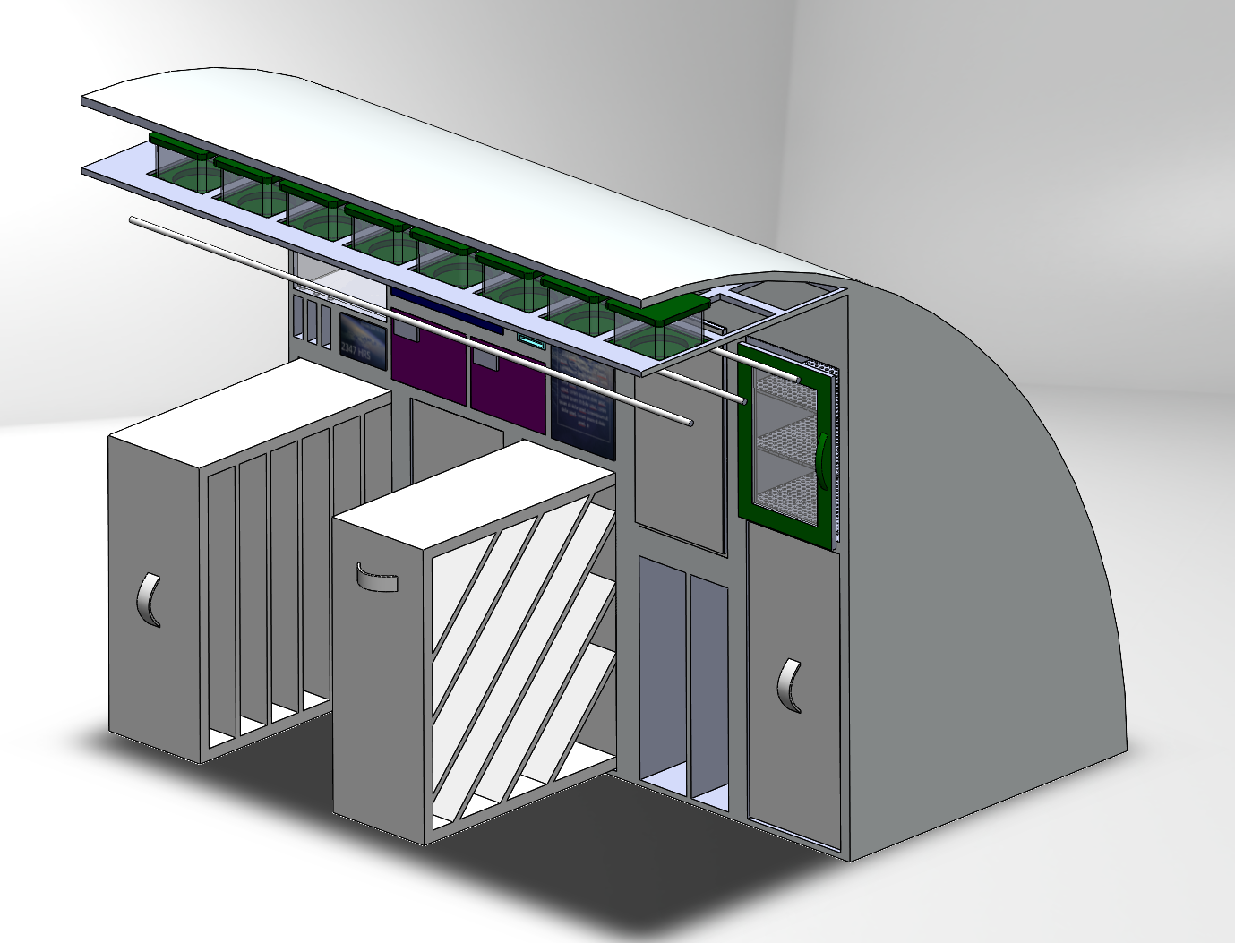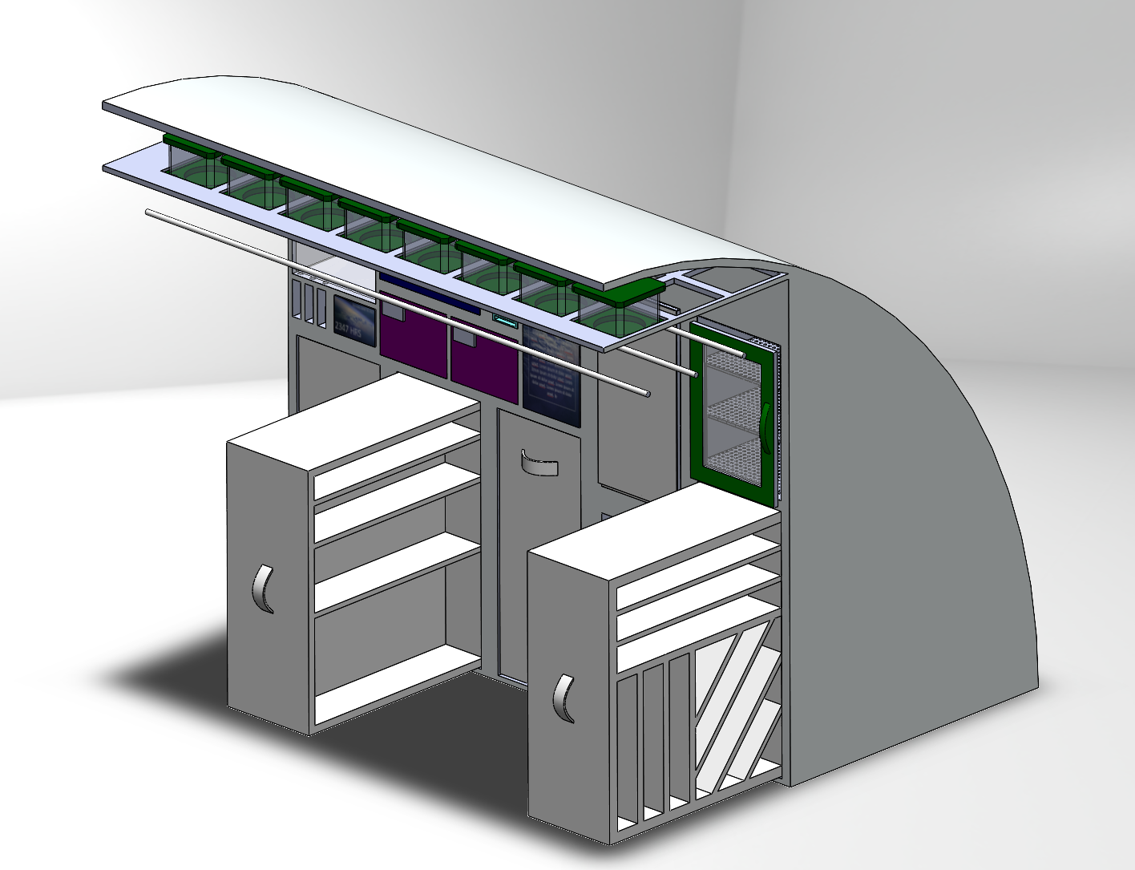

Figure 6. Galley with Different Storage Organization Options

The bottom row of the galley is fit with different options for storage to be tested during evaluations. The food stored there should be alphabetized for easier identification.

Under the fold out table there is a side for a small trash compactor and a side for a compost.

## Task Analysis

The Task Analysis seeks to provide a description of tasks that have to be performed by an astronaut with the galley system, which includes prepping meals, cooking, and cleaning. Task analyses also determine if the galley design fits within a habitable volume and if tasks can be completed within the expected time. One task analysis was done for meal preparation, one for cooking, and one for cleaning.

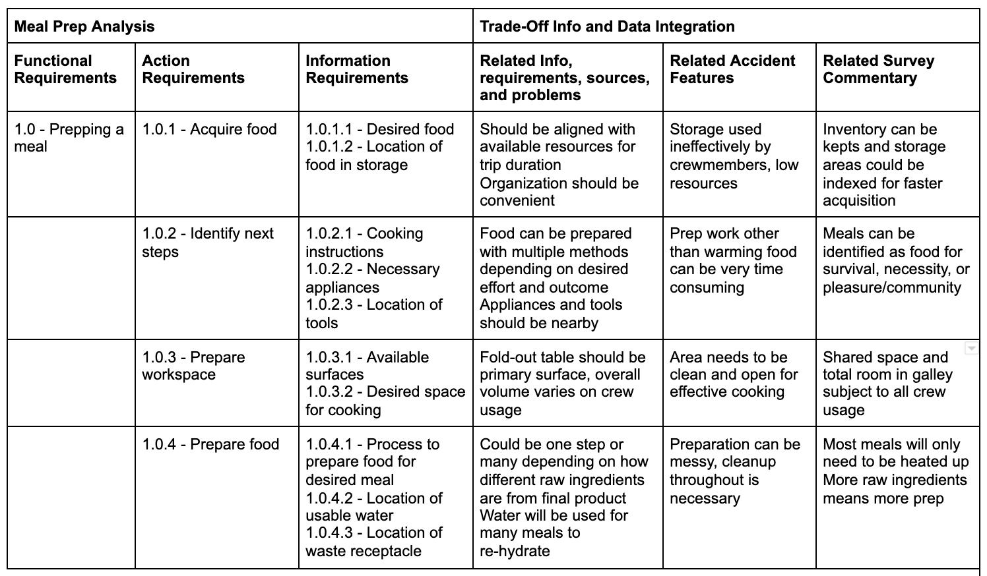

Table 1: Meal Prep Task Analysis

During the meal prep an evaluation of the cognitive workload can be conducted by measuring the heart rate during the prep. This can also be a measure of the physical exertion test subjects experience, but it is an easily implemented measurement. A line plot of the average heart rate during each of the steps of meal prep creates an inclusive picture of the cognitive workload during meal prep.

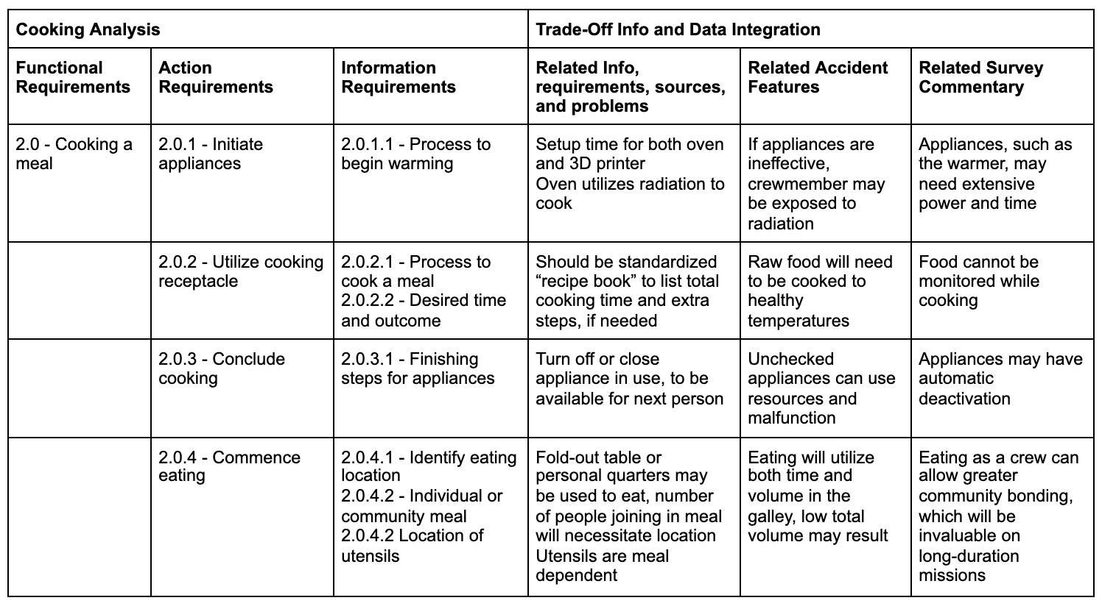

Table 2: Cooking Task Analysis

An evaluation of the cognitive workload conducted while subjects are cooking can be conducted by measuring the glance duration during meal prep. This measures whether the operation of appliances and displays showing cooking status are easy to understand. The glance duration can be plotted on a scatter plot and descriptive statistics can be used to understand the overall location and variability of the data.

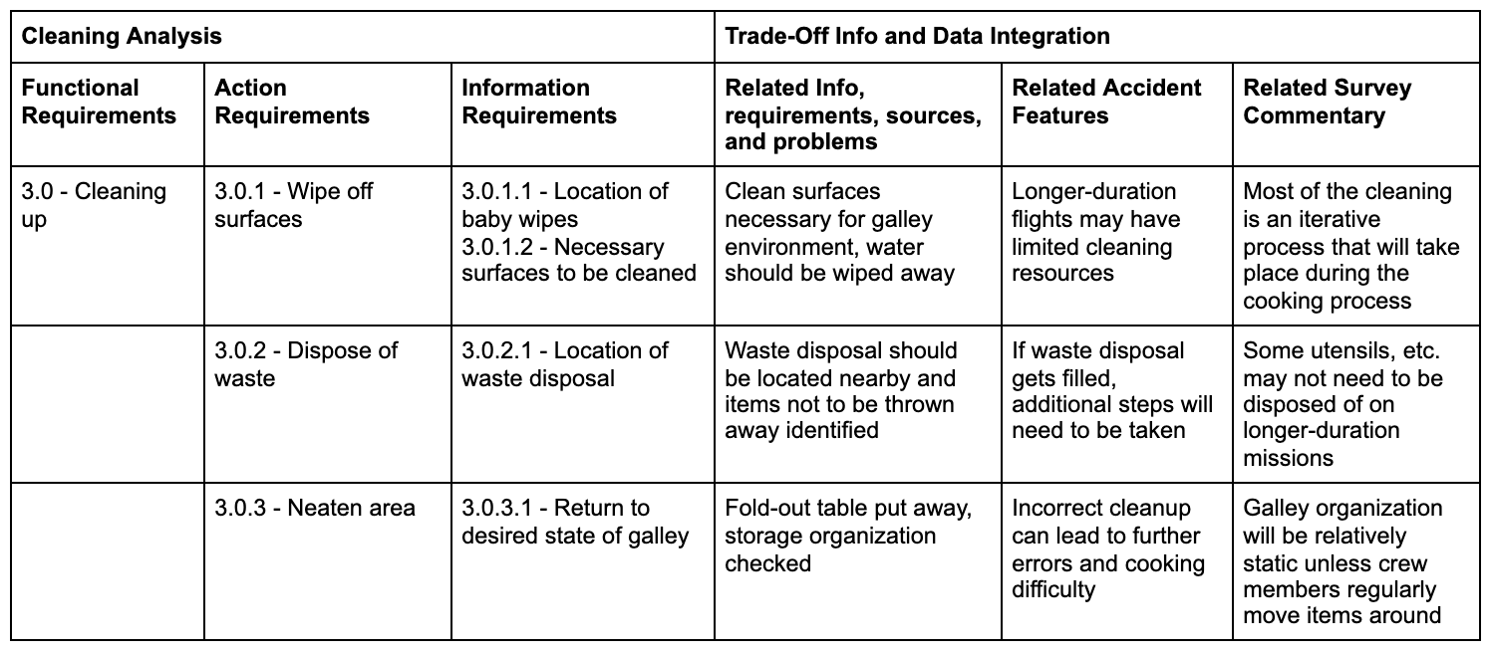

Table 3: Cleaning Task Analysis

The evaluation of cognitive workload during the cleaning task can be measured through a subjective survey, with a Cooper-Harper Scale. The Cooper-Harper Scale allows a clear standard of describing how easy it is to complete the task. A histogram of these answers will help reveal the general attitude around this task.

# Discussion

## Key Results

The requirement “The system shall provide the capability for preparation, consumption, and stowage of food” is addressed throughout every component of the design. The preparation of food is considered with the inclusion of an oven and potable water dispenser (BBC, 2020). As for stowage, there is a refrigerator, freezer, and plenty of high-volume storage compartments for the long-duration mission (Tarantola, 2020). Lastly, for consumption of food, the galley was designed with a built-in foldable table capable of accommodating up to 4 crew members.

The requirement “The food system shall allow the crew to unstow supplies, prepare meals, and clean up for all crew members within the allotted meal schedule” is addressed in the design of the galley with the inclusion of various components. The crew can unstow supplies by having the ability to open up the storage compartments to have access to anything inside. To prepare meals, there is an oven, potable water dispenser, and recipe control display to give instructions on how to prepare the food. Lastly, for cleaning up there is a built-in trash compactor and compost bin within the design of the galley.

The requirement “The food storage, preparation, and consumption areas shall be designed and located to protect against cross-contamination between food and the environment” is addressed in the design of the galley by having separate distinct areas for each stage of the food preparation process. There is an area for storage, preparation, consumption, and waste disposal incorporated into the galley. These components and compartments all work in tandem to satisfy this requirement.

The requirement “The system shall provide the capability to heat food and beverages to a temperature appropriate for the given item” is addressed with the incorporation of various systems to prepare foods. There is a potable water dispenser capable of dispensing hot or ambient temperature drinking water and there is an oven to heat foods to an appropriate and acceptable temperature.

The requirement “Crew Members shall have the capability to dine together” is addressed in the design of the galley with the incorporation of a fold-out table. The table is capable of accommodating up to 4 crew members at once while they consume their food. The fold-out design allows for the table to be open and closed as needed to save space in an already crowded environment.

The requirement “The system shall provide readily accessible trash collection and control of food system waste” is addressed in the design of the galley with the inclusion of the trash compactor and compost. The opening to both compartments is just behind the table once it is folded out allowing readily accessible disposal of waste during the processes of preparation and consumption of food.

The requirement “The system shall provide the ability to control and remove food particles and spills” is addressed in the design of the galley with the easily accessible and ready-to-use trash compartment positioned on one side of the fold out table. This will allow for the ability to remove food particles and spills using sanitary wipes or any cleaning equipment to clean the area for eating.

The requirement “The system shall provide methods for cleaning and sanitizing food facilities, equipment, and work areas” is addressed in the design of the galley with the easily accessible and ready to use trash compartment positioned on one side of the fold-out table to aid in cleaning and sanitizing the area. Disposable cleaning and sanitizing products can be used and disposed of within the compartment.

The additional requirement “The system shall allow storage with space for the food necessary for a 1-3 year long mission” is addressed with the multiple large storage capacity incorporated into the design of the galley. The storage compartments consist of the refrigerator, the freezer, the large dry nominal temperature storage shelves, and the freeze dried compartment. All of these compartments allow crew members to store food supplies for long-duration missions of 1-3 years.

The additional requirement “The system shall allow the dispensing of potable water” is addressed in the design of the galley with the incorporation of the potable water dispenser connected to the water filtration system. This system allows for the crew members to dispense drinkable water at ambient and warm temperatures.

The additional requirement “The system shall be equally accessible for all crewmembers, from the 95% American male to the 5% Japanese female defined by NASA-STD-3001 Vol 2 Rev B Section 4” is addressed in the overall sizing and dimensions of the design of the galley. The components sizes and equipment included were incorporated utilizing anthropometric data to design the galley in a way that is suitable for the crew's anthropometric range.

The additional requirement “The system shall have the capability of cultivating crops” is addressed in the design of the galley with the incorporation of a rack to hold and grow crops utilizing NASA’s Passive Orbital Nutrient Delivery System (PONDS). With the PONDS, crew members can grow crops and maintain them until they grow large enough to be moved into a facility more equipped for plant growth.

## Recommendations

The design currently has approximated dimensions for appliances that are contracted out. In the future, it will be necessary to procure the correct sizing.

It is recommended that a display is provided to help crewmembers cook, similar to a virtual assistant. This needs to be designed and included in the usability testing.

The current design assumes that because the galley lies in a common area that is not closed off from the rest of the spacecraft, the safety alarms in the rest of the common areas will work for the Galley as well. The current space station Galley does not have assigned safety alarms, however, the current space station galley does not have an oven. The confirmation of visual and auditory alarms assigned to the Galley is necessary for future designs.

# 

# Conclusion

In conclusion, the redesign of the Galley System for long-duration deep space missions is significant as it will aid in giving crew members a higher chance of survival with a higher food storage capacity for missions lasting 1-3 years. Our design builds off of the current Galley System design employed on the ISS that needs to be resupplied periodically. Due to the nature of deep space missions, our design incorporated high storage capacity, food preparation systems, and plant growth facilities capable of providing the crew with the means to have more food supplies than current systems. Without the ability to get supplies, the incorporation of facilities for plant growth allows for the crew to be able to replenish their food supplies and sustain themselves for the duration of the mission. Additionally, our design should be considered as it follows current NASA standards set in the NASA STD-3001 Ver 2 Rev B and builds upon those with our requirements for the benefit of deep space missions. The design overall has to be flexible, usable, and livable for the long-duration missions and with more research and development into our design, it has the potential for supporting the crew as they explore farther into space.

# References

BBC. (2020, January 24). Space cookies: First food baked in space by astronauts. Retrieved April 28, 2021, from <https://www.bbc.com/news/world-51235555#:~:text=Astronauts%20baked%20the%20cookies%20in,options%20for%20long%2Dhaul%20trips>.

Caldwell BJ, Halpern BP, Binsted K, Hunter JB. Menu Fatigue During 70-Day 6° Heat-Down Tilt: Initial Results. In: NASA Human Research Program Investigators' Workshop, Galveston, TX, 2014. NASA. <https://www.researchgate.net/publication/285057421_Menu_fatigue_during_70-day_6_head-down_tilt_initial_results>.

Curll M, DiNardo M, Noschese M, Korytkowski MT (2010) Menu selection, glycaemic control and satisfaction with standard and patient-controlled consistent carbohydrate meal plans in hospitalised patients with diabetes Quality and Safety in Health Care 19:355-359. <https://pubmed.ncbi.nlm.nih.gov/20693224/>

Dunbar, B. (2010, October 23). Food and cooking in space. Retrieved April 01, 2021, from <https://www.nasa.gov/mission_pages/station/expeditions/expedition18/journal_sandra_magnus_7.html>

Garfield, L. (2017, March 04). This robot can 3d-print and bake a pizza in six minutes. Retrieved April 28, 2021, from <https://www.businessinsider.com/beehex-pizza-3d-printer-2017-3#beehexs-bot-called-the-chef-3d-can-produce-any-type-of-pizza-in-any-shape-french-says-like-most-3d-printers-it-hooks-up-to-a-computer-that-tells-it-which-dough-sauce-and-cheese-to-use-1>

Hetherington M, Pirie L, Nabb S (2002) Stimulus satiation: effects of repeated exposure to foods on pleasantness and intake Appetite 38:19-28 <https://pubmed.ncbi.nlm.nih.gov/11883914/>

Human Research Program. (2016). [*Risk of Performance Decrement and Crew Illness Due to an Inadequate Food System*](https://humanresearchroadmap.nasa.gov/Evidence/other/AFT.pdf) (pp. 2-48, Rep.). Houston, TX: National Aeronautics and Space Administration.

Locher JL, Yoels WC, Maurer D, van Ells J (2005) Comfort foods: An exploratory journey into the social and emotional significance of food Food. <https://www.tandfonline.com/doi/abs/10.1080/07409710500334509>.

NASA. Figure 1. Space Shuttle Galley Design. Retrieved April 29, 2021, from <https://history.nasa.gov/SP-4225/diagrams/shuttle/shuttle-diagram.htm>.

NASA. Figure 2. Crewmembers gathering for a meal on the ISS. Retrieved April 29,2021, from <https://www.metropolismag.com/interiors/international-space-station-workplace-design/>.

NASA SPACEFLIGHT HUMAN-SYSTEM STANDARD (B ed., Vol. 2, pp. 75-81, Rep. No. NASA-STD-3001 VOL 2). (2019). Houston, Texas: National Aeronautics and Space Administration.

Shafiee, M. N. (2017). [Space Food Technology: Production and Recent Developments.](http://www.ijoart.org/docs/Space-Food-Technology-Production-and-Recent-Developments.pdf?fbclid=IwAR24icHZAH9T7aJ4l7y0hHt_-NADj-w7QG5qPARSP5dWrKyLsMFQcgeUkY8) *International Journal of Advancements in Research & Technology,* *6*(2), 120-129.

Shiraseb F et al. (2016) Higher dietary diversity is related to better visual and auditory sustained attention The British journal of nutrition:1-11 doi:10.1017/S0007114516000428. <https://pubmed.ncbi.nlm.nih.gov/26902532/>.

Tarantola, A. (2020, October 13). The international space station gets its first space refrigerator. Retrieved April 28, 2021, from <https://www.engadget.com/the-iss-gets-its-first-space-refrigerator-201241819.html>

Vickers Z (1999) Long-term acceptability of limited diets Life Support and Biosphere Science 6:29-33. <https://www.researchgate.net/publication/11803990_Long-term_acceptability_of_limited_diets>.

Zellner DA, Loaiza S, Gonzalez Z, Pita J, Morales J, Pecora D, Wolf A (2006) Food selection changes under stress Physiol Behav 87:789-793 [doi:10.1016/j.physbeh.2006.01.014](https://psycnet.apa.org/record/2006-04271-018)

# Appendix A

