**Final Report**

**for**

**Team 16:**

**San Antonio Lighthouse for the Blind 1**

Team members:

Brayden Parsons

Gabriel Rosas

Mitchell Schubert

Erin Sylve

Submitted to fulfill the requirement

for a final report in ISEN 460

Department of Industrial and Systems Engineering

Texas A&M University

December 12, 2021

Course Teaching Team:

Dr. Mark Lawley

Dr. Mike Graul

Mr. Jose Vazquez

Ms. Melissa Glass

Ms. Emilie Vawter

Ms. Michelle Hayek

Mr. Rafael Aguilar

Ms. Jainita Vinochandra

Advisor:

Dr. Mike Graul

Project Sponsor:

Pete Carrera, San Antonio Lighthouse for the Blind

**Acknowledgements**

The CAPSTONE Senior Design project gave us an opportunity to apply learned tools doing real project management and work with amazing professionals at the San Antonio Lighthouse for the blind. This allowed us to gain project leadership experience in a real-world setting and account for the results. In addition, we were able to meet project deadlines and milestones, and gain a richer understanding of project finances. Most importantly, witness the impact of project implementation, readjustments, and revisions necessary to produce an optimal solution on data analysis and deliverables. A huge thanks to Dr. Mark Lawley, Dr. Mark Graul, and Ms. Michelle Hayek for helping our group develop our communication and presentation skills, and providing feedback throughout the semester on the methods implemented in this report. Lastly, we would like to thank the entire team at the San Antonio Lighthouse for Blind for allowing us to work on this project and the kind people at The Lighthouse.

Brayden Parsons:

The first people I would like to thank are my parents who played a large role in motivating me to become an engineer and constantly reassuring me that I had the smarts and determination to make it through my classes when I was beginning to doubt myself. I would also like to thank my girlfriend who was always there for me when I was struggling in school and always offered to help me in any way she could.

Gabriel Rosas:

I would like to thank my family for guiding me through my college journey. They always supported me when I needed it the most. I would also like to thank all the staff and faculty that helped me learn the hard and soft skills on what it takes to become a successful engineer.

Mitchell Schubert:

I would like to acknowledge my friends and family who supported me throughout my time in college, and pushed me to become a better person each and every day. I would also like to thank the staff and faculty at Texas A&M who have done so much to provide such an amazing educational experience. Last but not least I would like to acknowledge all of the time and effort my teammates have put into this project. None of this would have been possible without their contribution.

Erin Sylve:

I’d like to thank my parents, who helped push me to keep going, even through rough times and my high school physics teacher, who believed anyone could be an engineer.

**Table of Contents**

**Executive summary ……………………………………………………………………………………………………… 6**

**Student ABET Feedback …………………………………………………………………………………………….… 7**

**Introduction and Background ……………………………………………………………………………………….8**

**Problem Statement ……………………………………………………………………………………………………....8**

**Scope ………………………………………………………………………………………………………8**

*Scope…………………………………………………………………………………………………………… 8*

*Complexity …………………………………………………………………………………………………………...…….. 9*

*Constraints ………………………………………………………………………………………...………………………. 9*

**Consideration of Risk …………………………………………………………………………………………………...9**

*Public Safety ………………………………………………………………………………………………………………..10*

*Public Welfare ……………………………………………………………………………………………………………...10*

*Global Factors …………………………………………………………………………………………………………...10*

*Cultural Factors ………………………………………………………………………………………………………... 10*

*Social Factors …………………………………………………………………………………………………………… 11*

**Recognition of Ethical and Professional Issues …………………………………………………………. 11**

**Standards and Codes …………………………………………………………………………………………………. 11**

**Methodology and Approach ………………………………………………………………………………………. 11,12**

*Alternatives ……………………………………………………………………………………………………………..*12,13

*Chosen Approach ……………………………………………………………………………………………………..*13

**Project Schedule …………………………………………………………………………………………………13,14**

**Analysis Outcomes and Findings ……………………………………………………………………………...14**

*Outcomes and Findings ………………………………………………………………………………………….*14-17

*Economic Analysis ………………………………………………………………………………………………….*17,18

**Conclusions and Recommendations ………………………………………………………………………..18**

*Conclusions ……………………………………………………………………………………………………………..*18

*Recommendations …………………………………………………………………………………………………..*18

**Skills and Capabilities Used in This Project …………………………………………………………….19**

**References ……………………………………………………………………………………………………19**

**Appendix ……………………………………………………………………………………………………20**

*Appendix A: ISO 9000 Standard Principles*

………………………………………………………………………………………...20

**List of Figures**

**Figure 1: Facility Layout**

**Figure 2: Painting Room**

**Figure 3: Production Area**

**Figure 4: Spaghetti Diagram**

**Figure 5: Value Stream Map**

**Figure 6: Simio Model 1**

**Figure 7: Simio Model 2**

**Figure 8: Economic Analysis**

**List of Tables**

**Table 1: Production Process**

**Table 2: Decision Matrix**

**Table 3: Project Schedule**

# **EXECUTIVE SUMMARY**

For this project we were assigned the task of increasing the output of the Lighthouse for the Blind’s KC-135 aircraft floorboard production from 5 to 7 kits per month while maintaining safety standards for its employees. We first had to visit the warehouse and do an analysis of the company’s current production system in order to find areas that we think could be improved. During this process we were able to develop time studies, simio simulations, and reorganization of product plans to increase the production of floorboards. Additionally, we centered the design around the fact that 75% of the warehouse’s workforce has visual impairments whether it be tunnel vision, peripheral vision, or partial/full blindness. We made sure that our solution was structured around this aspect to ensure worker safety, customer satisfaction, and develop a production plan that does not require additional training.

**STUDENT ABET FEEDBACK**

Use the table below to indicate the ABET outcomes your team experienced in the course by placing an “X” in the applicable box. Please include any comments to help us understand your response, but note that what is really helpful for you to consider in your response is: Did the course provide an opportunity for you to demonstrate your ability in each outcome. If “yes” how; if “no” why was that the case.

| ABET Outcomes | Yes | No |
| --- | --- | --- |
| (1) an ability to identify, formulate, and solve complex engineering problems by applying principles of engineering, science, and mathematics; | X |  |
| Comment: This was done through various analyses as seen in section 6. | | |
| (2) an ability to apply engineering design to produce solutions that meet specified needs with consideration of public health, safety, and welfare, as well as global, cultural, social, environmental, and economic factors; | X |  |
| Comment: Completed through the chosen solution alternative that considered the human factors element in this project. This is further explained in section 3. | | |
| (3) an ability to communicate effectively with a range of audiences; | X |  |
| Comment: Group 16 effectively communicated with engineers, supervisors, and a wide range of employees at the San Antonio Lighthouse for the Blind. | | |
| (4) an ability to recognize ethical and professional responsibilities in engineering situations and make informed judgments, which must consider the impact of engineering solutions in global, economic, environmental, and societal contexts; | X |  |
| Comment: Public safety, public welfare, and global factors were considered when determining the final solution alternative. This is further explained in section 3 and 4. | | |
| (5) an ability to function effectively on a team whose members together provide leadership, create a collaborative and inclusive environment, establish goals, plan tasks, and meet objectives; | X |  |
| Comment: The final report demonstrates the entirety of this project and adheres to this objective. | | |
| (6) an ability to develop and conduct appropriate experimentation, analyze and interpret data, and use engineering judgment to draw conclusions; and | X |  |
| Comment: The use of Simio and Economic analysis demonstrate how data was used to draw conclusions regarding the production process at the Lighthouse. | | |
| (7) an ability to acquire and apply new knowledge as needed, using appropriate learning strategies. | X |  |
| Comment: | | |

# **1.0 INTRODUCTION & BACKGROUND**

# Our project is sponsored by the San Antonio Lighthouse for the blind. The Lighthouse was founded in 1933 and operates as a non-profit organization that is funded through government grants. They provide rehabilitation services as well as employment for the blind and visually impaired through its manufacturing and assembly plant. Since its founding, The San Antonio Lighthouse has grown to 475 employees and has expanded to 14 locations across Texas, Oklahoma, and New Mexico.

Currently, The Lighthouse produces small textiles, office equipment, and small grade military instruments including helmet chin straps, mechanical pencils, absorbent products, highlighters, and most recently floorboards kits for KC-135 aircraft. The Lighthouse is also ISO9001 and AS9100 certified, which ensures top quality management systems in manufacturing and aerospace industries.

The first section of this report will be an overview of The Lighthouses’ problem statement and the scope, constraints, and considerations used to create a solution. This section will highlight the safety requirements used by the company and will share how the optimization introduced affected the outcomes of the process while still meeting the deliverables set.

The second section of the report will introduce the methodology and approach used in the developing process. The discussion will first introduce the performed operations analysis with a curated inherently safer design to accommodate the visually imparied. The economic viability will be shown, providing insight on the level of profitability of the current design. In addition, a project schedule is included to map out the time allotted to each activity throughout the semester.

The fourth section will discuss conclusions and recommendations based on the research and findings that were realized throughout the process of finalizing a solution. A proposed production plan and layout it presented in this section of the paper.

**2.0 PROBLEM**

## **2.1 PROBLEM STATEMENT**

The initial problem statement provided by the department was as follows, “The Lighthouse wants to expand its manufacturing to pursue more opportunities in the aerospace industry. How does it do this while maintaining current production?”. After meeting with the company and discussing the production process we created a revised problem statement that better suits The Lighthouse’s goals in the aerospace industry as stated below.

Problem statement: The San Antonio Lighthouse for the Blind seeks to increase production of KC-130 floorboard kits from 5 to 8 per month while maintaining a safe work environment for the visually impaired.

## **2.2 SCOPE**

**2.1.1 SCOPE**

The project scope includes increasing the floorboard production from 5 to 8 kits per month while adhering to the AS9100, ISO9001, and OSHA requirements. The material used for the production is plywood and should not require adjustment in the selection of materials for all unit operations to maintain the same activities in the production process. The solution seeks to reduce motion for the workers between transport stations and allow easier methods for the visually impaired to work. Parameters include maintaining a minimum of 75% visually impaired employees, decreasing the process cycle time from 8 to 5.7 per hour, and increasing the accessibility for the visually impaired. This is anticipated to increase the production of floorboards during a given month at a reasonable cost. Assumptions that were made during the project include variation in time studies of certain activities due to the time duration of completing a single kit. Visuals of the completed floorboard kit, facility layout, and activities in the process in section 6 of this report.

**2.1.2 COMPLEXITY**

The complexity arises in the form of a human factors problem. The entire production process is operated by the visually impaired. This is a factor that is put at the forefront of our project while creating optimal solutions and deciding whether or not certain activities should be implemented into the process. It is also important to note that there are various forms of visual impairment including tunnel vision, peripheral vision, and full blindness. Depending on the level of visual impairment certain employees may operate certain stations.

## **2.3 CONSTRAINTS**

Design standards and constraints are critical in the engineering design process. These constraints and standards are critical to ensuring the safe and responsible practice of engineering both within the company’s boundaries and in the context of broader effects on its workers. In this section, constraints and standards applied to this project are discussed. Additionally, an index of these constraints and standards can be found in the appendix.

One major constraint for the development for the production plan of an extensive warehouse is the economic constraint of overall additional costs. The Lighthouse is a non-profit organization that operates on government funded grants. Based on this, there is limited funds that the company can allot to this project given the need to submit proposals and approval of additional funds. With that being said, the solution provided had to develop a plan that did not require additional training to keep the current production process on track with its contract with the US Military.

Another major constraint associated with this project was the limitation of certain stations in the facility layout. The first is the CNC Machine, as seen in *figure 1*, that cuts wood to certain dimensions for KC-135 aircraft floorboards. This is a large machine that takes up an entire area of the warehouse. Therefore, the CNC Machine cannot be moved from its location and is considered a constraint when developing an optimal facility layout. Another area that cannot be moved is the paint and curing station. This is a large metal room, as seen in *figure 2*, that is stationary in location and is also considered in the facility design.

Additionally, the use of plywood and paint is also payed close attention. Since both of these materials are highly flammable, the implementation of additional products and activities were both considered in both environmental and ethical ramifications. The use of a high heat environment creates a safety hazard for the employees, eliminating the use of a laser cutter or various tools to speed up cutting and sanding processes.

## **3.0 CONSIDERATION OF RISK**

**3.1 AREAS OF CONSIDERATION**

**3.1.1 PUBLIC SAFETY**

Public safety is probably the most directly connected area of consideration for our project. The US military is usually the first institution that comes to mind when one thinks of public safety in the United States and with the Lighthouse being involved in the production of KC-135, a military fueling aircraft, they play a role in contributing to public safety. Ensuring that all military aircrafts are properly fueled is an important aspect in keeping America’s airspace safe from any possible threats.

**3.1.2 PUBLIC WELFARE**

The provision of skill-based jobs to the blind and visually impaired promotes the welfare of the general public. It allows the disabled to support themselves and feel valued in the society they live in. By keeping the amount of visually impaired people able to work in this process above 75%, this project is helping to promote the welfare of these workers, which promotes the welfare of society as a whole. San Antonio Lighthouse for the Blind also plays a role in the public welfare of US citizens. The US military’s primary goal is to preserve America’s core values and ensure that our country remains prosperous and free. So, with the Lighthouse having a direct connection to the military that means that they are a contributing factor to America’s welfare because they play a role in keeping our Air Force adequately stocked with aircrafts which are an essential part of maintaining our country’s significance on the world stage.

**3.1.3 GLOBAL FACTORS**

Since Lighthouse for the Blind has a contract with the US military there are many global factors that are attributed to them. The US military has bases all throughout the globe in order to ensure the safety of both the American people and the people of allied foreign nations. The rate and quality of the production of KC-135 floorboards can have a direct impact on the military’s ability to effectively operate these bases to more confidently ensure the safety of various people all over the world. Considering that the KC-135 aircraft’s purpose is to refuel other military aircrafts while still airborne, it is important that the Lighthouse’s production is maximized so that the other aircrafts are able to be fueled adequately and minimize the chance that aircrafts run out of fuel while in use.

**3.1.4 CULTURAL FACTORS**

A major factor associated with this project was the considerations of risk that can be minimized for the operation of The Lighthouse. The first area considered are cultural factors. The entire production team are people that have some level of visual impairment. Our team had to learn about the various types of visual impairment to get an idea of how this changes how employees can perform certain activities. There are four levels of visual impairment that include mild with visual acuity worse than 6/18, moderate with visual acuity worse than 6/60, severe worse than 3/60, and blindness with visual acuity worse than 3/60 (WHO). Additional terms used by the visually impaired community include tunnel vision, peripheral vision, and full blindness. Most of the employees have a level of moderate to severe impairment and have a form of tunnel vision that allows them to see various shapes and colors that enable them to perform sanding activities with an orbital sander. The levels of vision were considered when implementing additional tools that would help speed up the sanding process and allow for easier movement around the facility with our layout.

**3.1.5 SOCIAL FACTORS**

The last consideration made was regarding the social factors of working with the visually impaired. Included in the Disability Language Style Guide it is noted that, “unless the person refers to himself or herself as legally blind, the term ‘low vision’, ‘limited vision’, or ‘visually impaired’ should be used.” [1]. This recommendation helps provide a safe and welcoming environment for the people at The Lighthouse.

## **4.0 RECOGNITION OF ETHICAL AND PROFESSIONAL ISSUES**

One of the major areas of concern that we prioritized when brainstorming ideas for increasing production was the fact that essentially all of the workers within the Lighthouse for the Blind’s workforce have a visual impairment. So, whenever we contemplated a solution we always made sure that we kept this in mind so that our final solution was considerate of the visually impaired and ensured that our proposed system improvement was both safer and easier for the workers than their current system.

# **5.0 STANDARDS AND CODES**

San Antonio Lighthouse for the Blind is subject to several standards and codes which can influence their methods of operation. The first one that they must follow is the AS9100 standards which deal with production operations for the aerospace industry. The contents of AS9100 are fairly similar to those of the ISO9000 standards however it is geared more towards aerospace.

The next set of standards that they are subjected to is the ISO 9000 standards which is related to quality management systems. The seven aspects that are specified within the ISO9000 standards include: customer focus, leadership, engagement of people, process approach, improvement, evidence-based decision making, and relationship management.

# **6.0 METHODOLOGY/APPROACH**

In this section the methodology used to determine our chosen solution alternative is presented. To give an understanding of our solution alternatives, a table of the activities in the production process is given below. In addition, a layout of the facility, and a few figures of the facility to give a visual of stations in the production process.

**Table 1: Production Process**

| 1 | 2 | 3 | 4 | 5 | 6 | 7 | 8 | 9 |
| --- | --- | --- | --- | --- | --- | --- | --- | --- |
| CNC Machine | Sand Hard Edges | Sand With Orbital Sander | Clean | Prime | Re-Sand | Clean | Paint/Curing | Packaging |

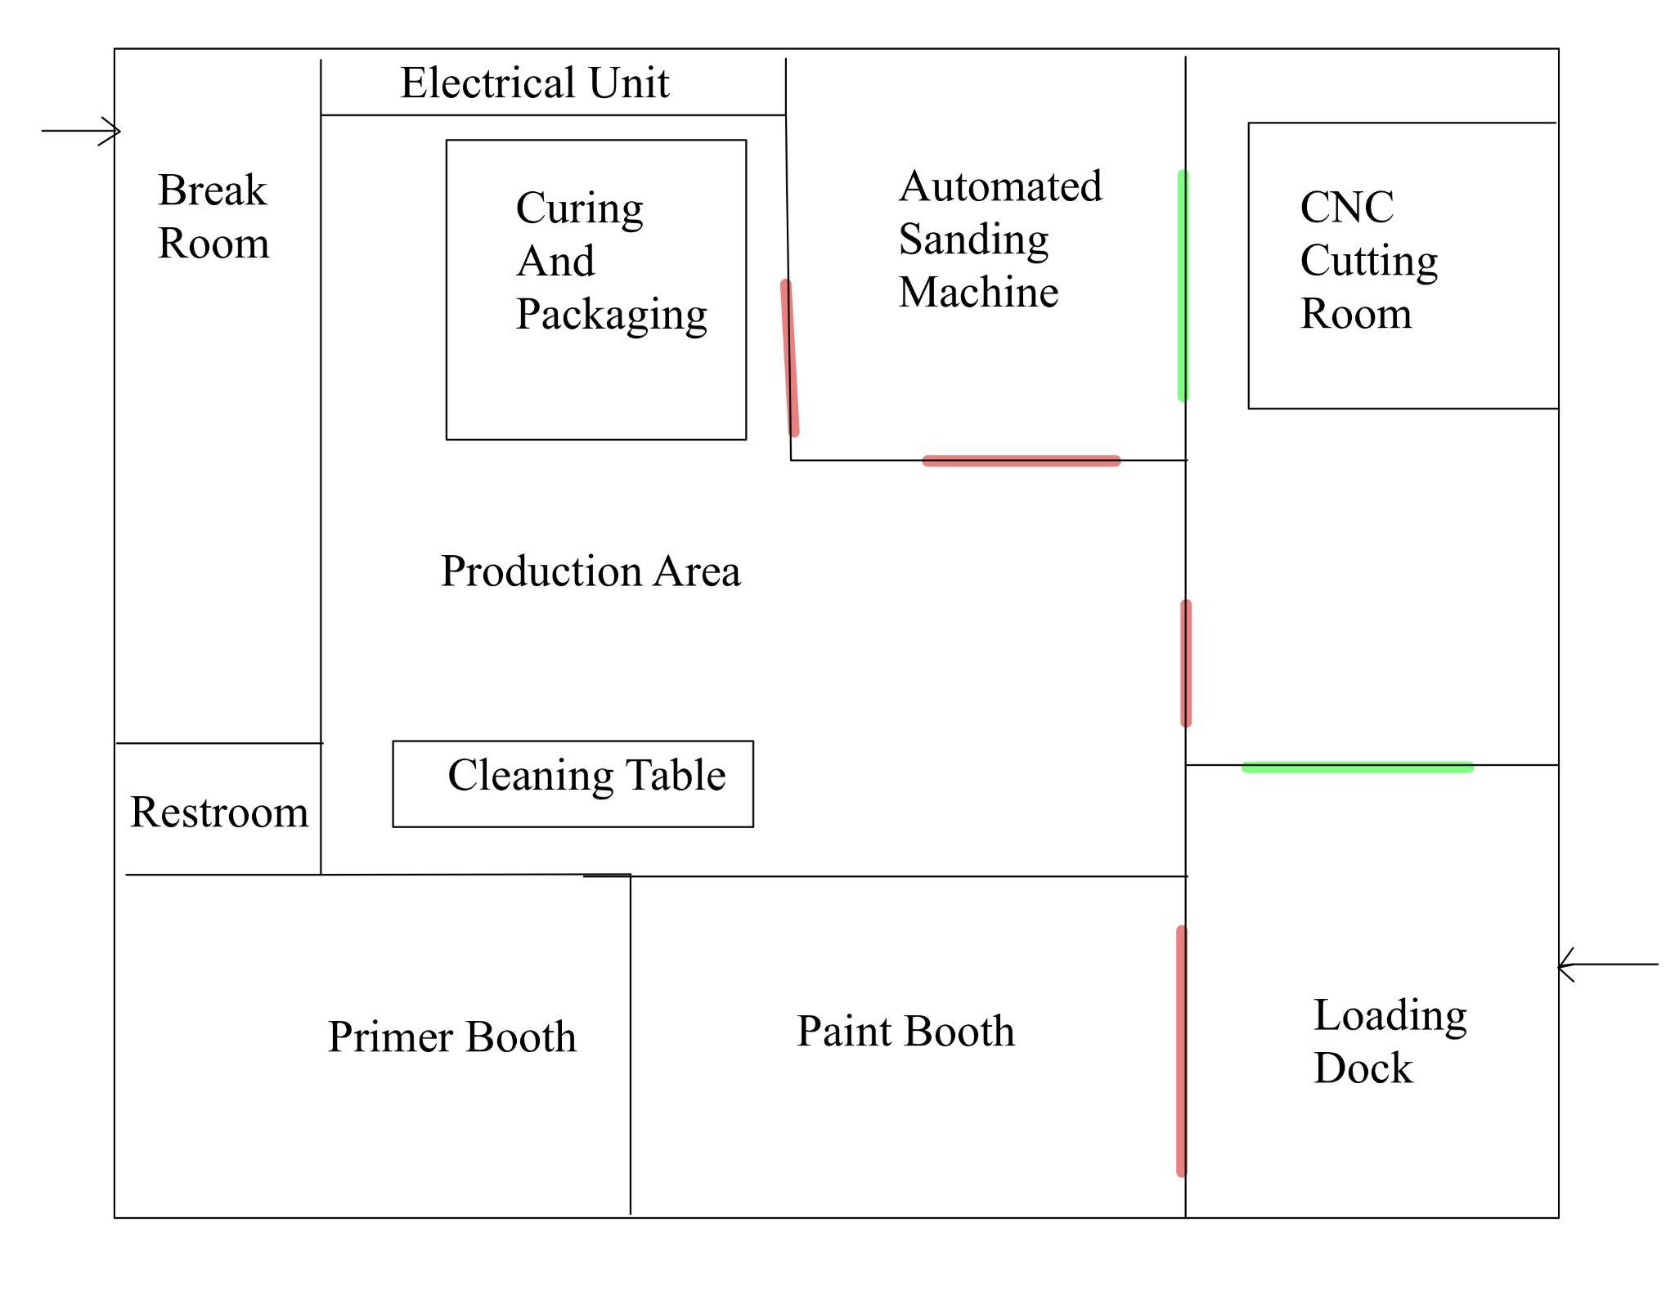

**Figure 1: Facility Layout**

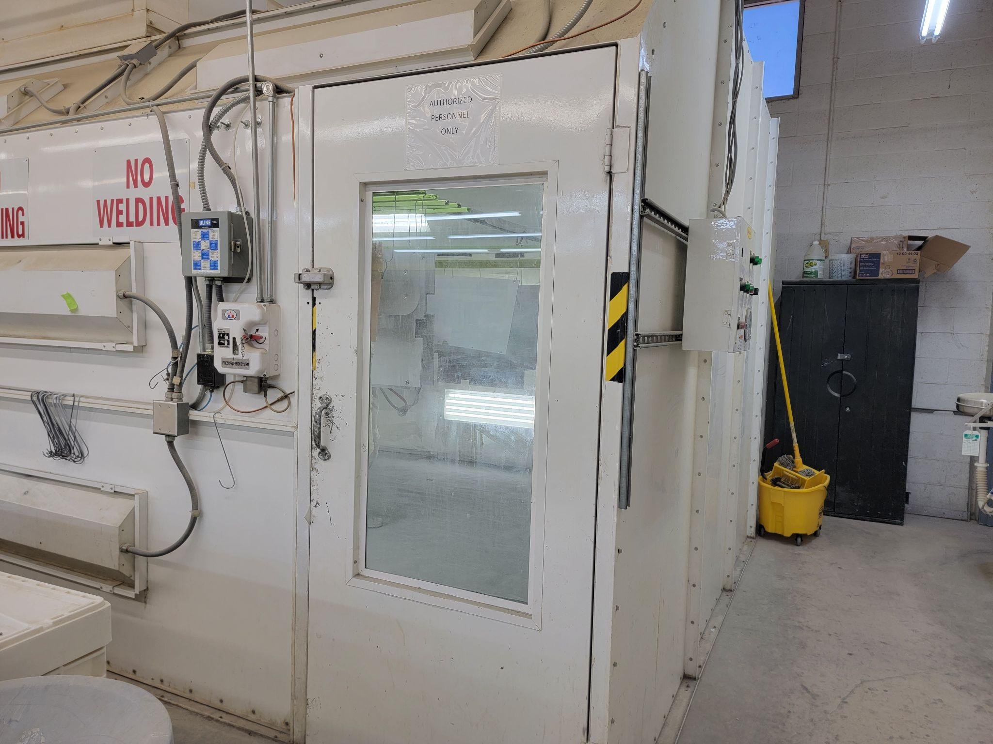 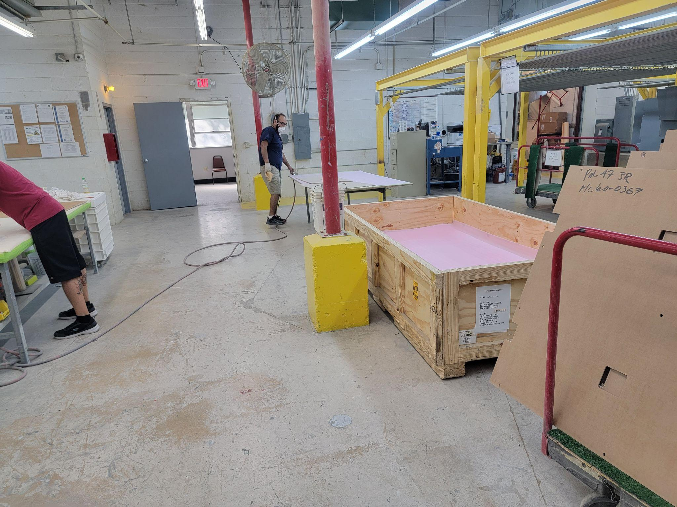

**Figure 2: Painting Room Figure 3: Production Area**

**6.1 ALTERNATIVES**

The options determined in the first round of creating solution alternatives are as follows:

1. Move sanders to reduce movement.
2. Eliminate re-sanding process to speed up production time.
3. Rearrange stations to improve production flow.
4. Change process to maximize the number of floorboards in the painting area at once.
5. Move from batch to single item processing
6. Optimize CNC pattern with fileted/chamfered edges
7. Less time waiting on curing
8. Do nothing alternative

The following options were created from to address in the problems chosen from the previous round of alternatives:

Edge Sanding Options:

Add a new sanding/chamfer tool for the CNC to follow with the same

Add an additional step of making a small chamfer with a handheld router

Add additional hand sanding workstations

Single Piece Flow Options:

New Process Flow = Old Flow but one at a time

Pieces are CNC’d in a pattern that optimizes speed and reduction of waste, moves through the system, and are sorted at the end.

Pieces are marked with ID and produced as needed.

**6.2 CHOSEN APPROACH**

Because the problem statement given was so undefined, several interactions of creating solution alternatives were necessary. The first set of requirements created were to address the need for process improvement. Through facility analyses the need was further defined. New requirements were specified. A set of alternatives were created to meet the currently defined need. Of the solutions, an evaluation was conducted to determine which solutions best decreased cycle time, while operating within the given constraints. The decision matrix used is pictured below. From this decision matrix, more insight to the necessary approach was shown and the constraints of the standards became better understood.

**Table 2: Decision matrix**

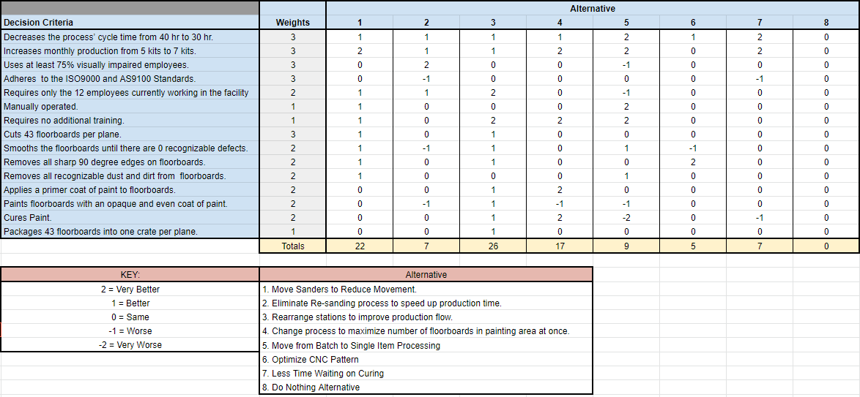

# **7.0 PROJECT SCHEDULE**

Throughout the semester our group was able to document key milestones and deliverables that were fundamental to completing this project. Below is a table of each milestone, the date of completion , and a short description of what the activities entailed. It is also important to note that the key milestones listed are main tasks and additional time was allotted to the project by each team member.

**Table 3: Project Schedule**

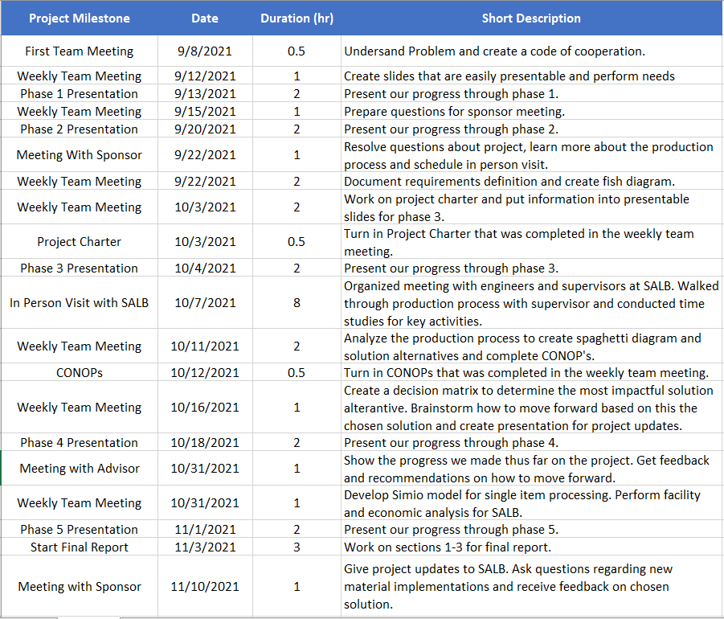

# **8.0 ANALYSIS OUTCOMES AND FINDINGS**

**8.1 OUTCOMES AND FINDINGS**

Displayed below are the various figures and accompanying explanations that were used in order to effectively analyze the current production system and find areas of improvement. The areas that we used to break down the Lighthouse’s system include the layout of the facility, the current methods of production, and economic factors which all played a role in the creation of the system that is currently set in place.

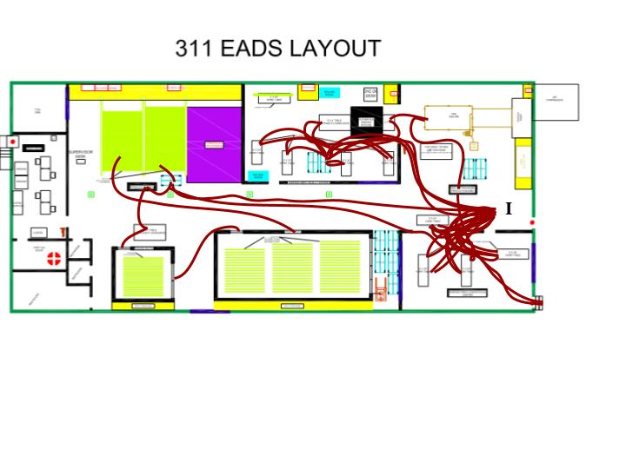

**Figure 4: Spaghetti Diagram**

Pictured above, the Spaghetti Map shows the path a single floorboard may take across the facility. The board will enter and exit through the door at the loading dock on the lower right. Upon entry, the raw boards are set in a stack, where they will wait until the CNC is ready to process them. Once the CNC has cut a floorboard it goes through the timesaver and then heads to the orbital sanders. Between each step of the process, boards wait on a cart until each of the 43 floorboards in a kit has completed the last step. Next, the edges of the boards are sanded down by hand until smooth to the touch. Boards are coated in primer and sent through sanding steps again. This is where the spaghetti diagram shows a lot of crossover. This is shown with the additional inventory between each step as well. The final steps of the process show the work that has been done to make them more efficient. Between priming, painting, and curing there is no jumbled movement.

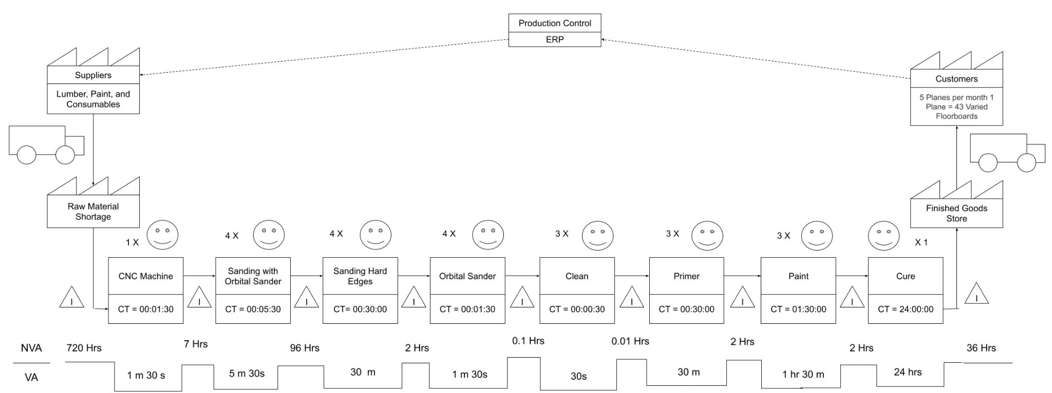

**Figure 5: Value Stream Map**

The Value Stream Map pictured above shows the time spent in each step of the process. An evaluation is conducted of the time spent in value added steps. The value added steps were determined to be any step required by the customer’s standards or a step that changed the product significantly.

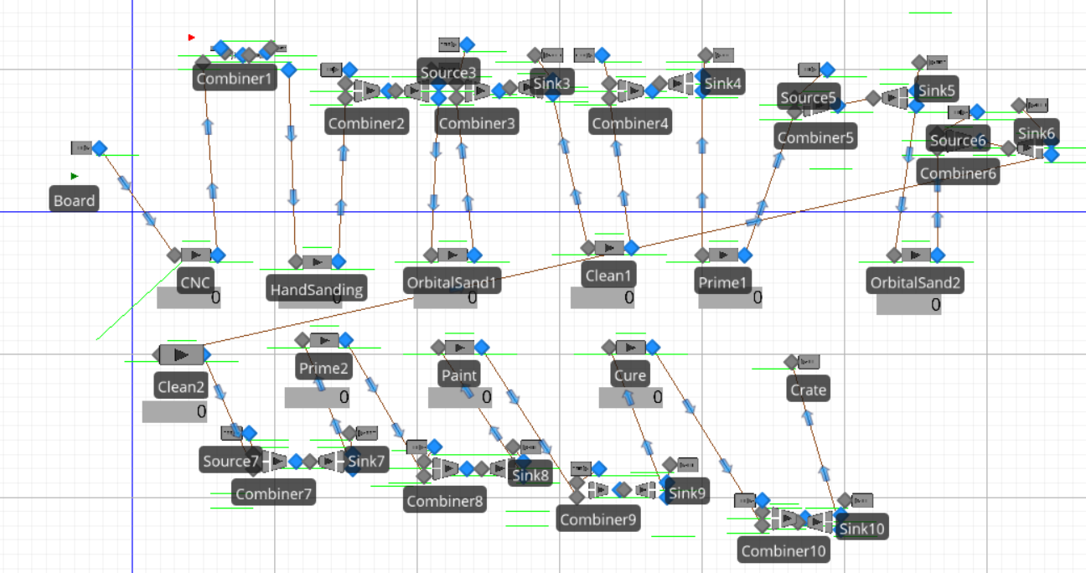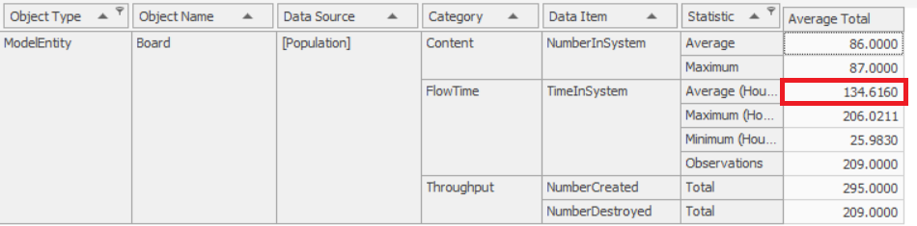

**Figure 6: Simio Model 1**

The current production process is being run in a batch process configuration. More specifically, each board in a kit is waiting for the entire set of 43 boards to finish one step in the process before they all move on to the next step. This batch processing of boards was modeled in a Simio model that represented an estimation of the floorboard production process. As expected, Simio demonstrated that the average Time in System for a single board is excessive (~135 hours each). This is one measure that the project sought to optimize for the Lighthouse.

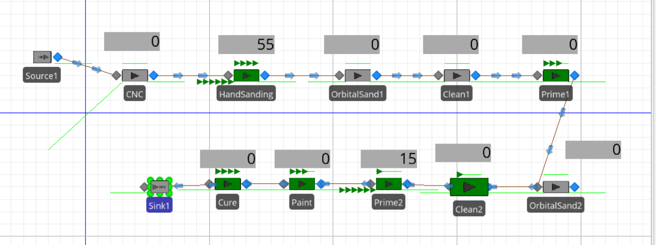

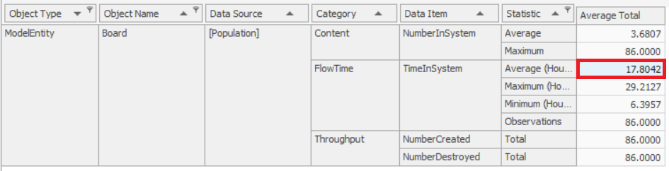

**Figure 7: Simio Model 2**

In order to apply Lean manufacturing, the model was changed to represent each board in the process moving on to the next step as soon as it was done with the current step. This change made for a much cleaner Simio model, as well as a drastic decrease in average Time in System for each board. This is what is expected of Single Item Processing versus Batch Processing. Even after assuming some inaccuracies in both models, the difference in the Time in System is staggering.

**8.2 ECONOMIC ANALYSIS**

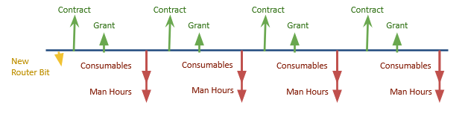

**Figure 8: Economic analysis**

The prices for a handheld router, chamfer router bit, and sanding bits are detailed below. Because the money the lighthouse receives is in the form of contracts, there is not revenue gained, but costs recuperated. By moving to single piece flow and purchasing a new router bit, the amount of man hours going into producing each kit of floorboards is reduced. By lowering the amount of manhours going into producing each kit of floorboards, the cost per kit is reduced and the U.S. Air Force is more likely to choose the San Antonio Lighthouse for the Blind to fulfill future contracts.

# **9.0 CONCLUSIONS AND RECOMMENDATIONS**

**9.1 CONCLUSIONS**

When our team observed the current production system that the Lighthouse for the Blind uses we could clearly see that the hand sanding station was the bottleneck with some floorboard panels taking upwards of 45 minutes to complete. We also observed that the time that a panel spent in the hand sanding station varied drastically, the time that it took depended mostly on both the size and the number of cuts that were made within each panel.

Additionally, their current strategy of keeping all of the floorboards that are in a kit together created a pile up of unfinished kits which took up a good amount of space within their warehouse. Their reason for doing this is so that they are able to ensure that all 43 panels in a kit stay together minimizing the chance of one part getting lost.

Lastly, if we are able to solve the hand sanding bottleneck, then it is highly likely that the painting station would become the new bottleneck because they have to let the panels dry for 24 hours. Unfortunately, there is not much that we can do to reduce this time unless they implement a type of heating station which could potentially speed up the drying process. However, obtaining equipment that is capable of this could be fairly costly and take a while to install into their warehouse.

**9.2 RECOMMENDATIONS**

Considering that hand sanding is the current bottleneck of the system, we felt that it was only logical that this would be the station that we sought to speed up when coming up with solutions. We believed that the best solution to solve this problem would be to either implement a sanding tool to the CNC machine itself so that the cutting and edge sanding were both taken care of in a single station or introduce the idea of investing in a handheld router sander which is much more efficient than traditional hand-sanding. Both of these solutions would require very little training to learn how to operate plus it will make the edge sanding step much less strenuous than the current method.

Another recommendation that we have is for them to transition to a one part at a time approach when producing the floorboard panels rather than keeping them in their batches. In order to satisfy the need of keeping all panels within a kit together, we suggest creating a system where they mark each of the panels so that they are able to keep track of all the floorboards within a kit without having to keep all of the floorboard panels together which creates a lot of unfinished inventory that takes up a lot of space in the warehouse.

## **10.0 SKILLS AND CAPABILITIES USED IN THIS PROJECT**

Table 1: Skills and Capabilities

| Course | Skill/Capability |
| --- | --- |
| ISEN 210 | Decision matrix, fishbone diagram, cash flow diagrams, & spaghetti diagram |
| ISEN 355 | Simio |

## 11.0 REFERENCES

[1] Disability Language Style Guide, <https://ncdj.org/style-guide/>

[2] ABET. [Online]. Available: <https://www.abet.org/accreditation-criteria/criteria-for-accrediting-engineering-programs-2018-2019/>. [Accessed Nov 1 2021]

[3] NSPE Code of Ethics for Engineers, [Online]. Available: <https://www.nspe.org/resources/ethics/code-ethics>

[4] San Antonio Lighthouse for the Blind About Section. [Online]. Available: <https://www.salighthouse.org/about/>

[5] ISO 9000 Standards Guide [Online]. Available:

<https://asq.org/quality-resources/iso-9000>

12.0 APPENDIX

12.1 Appendix A: ISO 9000 Standard Principles

